# **Standard Deviation Bar Visual – Support Document**

# **Overview**

This guide provides step-by-step instructions on how to prepare and display the Standard Deviation Bar Chart in Power BI. While powerful, this visual requires a specific data structure to render correctly. If the setup isn’t followed, the visual will not appear or may produce misleading results.

# **How the Visual Works**

The Standard Deviation Bar Chart displays both the average and the standard deviation of numerical values for each category. This is particularly useful for understanding variability or volatility in data over time.

# **Getting Started: Example Walkthrough**

# **Step 1: Prepare Your Data**

Proper data formatting is critical for this visual to work. Your dataset should be structured in a two-column format:

Column 1: Category – A text-based field (e.g., product name, region, department).  
 Column 2: Value – A numerical field representing a measured quantity (e.g., price, sales, count).

Example Use Case:  
 You’re analyzing the monthly prices of five types of apples in 2024. You collected 12 price samples (one per month) for each apple variety. Each row in the table represents one sample, with the apple variety as the category and the price as the numerical value.  
 When configured correctly, the visual will display:  
 - A bar representing the average price for each apple type.  
 - Error bars representing the standard deviation, showing how much prices varied throughout the year.

# **Step 2: Load the Data into Power BI**

1. Open Power BI Desktop.  
 2. Load your dataset into the data model.  
 3. Ensure the two required columns are present and correctly formatted:  
 - Category column (text)  
 - Value column (number)

# **Step 3: Add the Standard Deviation Bar Chart Visual**

1. In the **Visualizations** pane, select the **Standard Deviation Bar Chart**. A visual placeholder should appear on your report canvas.

2. In the **Fields** pane on the right-hand side, first select the **Category** column by checking its box. *(The order of selection is important.)*

3. Next, check the box for the **Value** column to add it to the visual.

4. Once both fields are assigned, the chart should populate with data. You can now adjust formatting and styling options in the **Format** pane, just like with any other Power BI visual.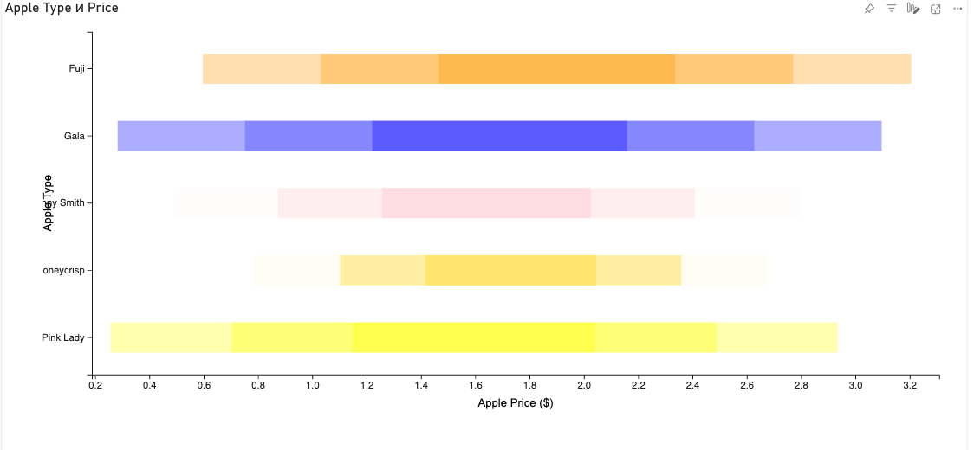

**Step 4: Interpret the Results**

**Step 4: Interpret the Results**

• **Center of the bar**: Represents the **mean (average)** value for each category.

• **Shaded bands**: Indicate **1, 2, and 3 standard deviations** from the mean, with varying levels of shading to show the range of variability.

When you **hover over a bar**, a tooltip will display detailed statistics, including the average value and standard deviation for that category.

For example, in the visual above, **Honeycrisp Apples** show the **lowest standard deviation**, meaning their prices remained the most stable over the year. This insight can be valuable in operational decision-making. If you’re planning to sell more Honeycrisp apples, the consistent pricing may allow for **more predictable revenue forecasting**.

This kind of analysis can also support decisions like:

• Determining how much to **borrow** for purchasing inventory.

• Deciding which apple types to **buy in bulk** from suppliers for the upcoming season.

Understanding variability helps reduce risk and plan with greater confidence.

# **Common Issues & Troubleshooting**

If your Standard Deviation Bar Chart isn’t rendering correctly, consider the following common causes:

**1. Too Many Columns Selected**

*You have selected more than two columns, which causes the visual to misinterpret the data structure and fail to load. Please ensure only one category column (text) and one value column (numeric) are selected.*

**2. Incorrect Data Types**

*The selected columns must include a text-based category and a numeric value. If the data types are mismatched, the visual will fail to render properly. Please verify your columns are correctly formatted.*

**3. Too Many Categories**

*The visual may not load if there are too many unique categories, especially if the dataset is large. Try filtering or grouping your data to reduce the number of distinct categories shown.*

**4. Skewed Data or Outliers**

*If your dataset contains extreme outliers or isn’t normalized, the chart may display one dominant bar while others appear nearly invisible. Consider applying normalization or excluding outliers to improve the readability of the visual.*

# **Need Further Assistance?**

If you encounter issues or have questions, reach out to support@skillwill.org for assistance.